CSA1708-ARTIFICIAL INTELLIGENCE
LAB EXPERIMENTS
Program 19 : Prolog Program for Student Teacher Subject Code Database
Aim
To create a Prolog database that connects students with their teachers and subject codes.
Algorithm
1. Store student IDs with student names as facts.
2. Store teacher IDs with teacher names as facts.
3. Add facts linking each student and teacher to a subject code.
4. Use a rule to join the facts and return a student's teacher and subject code.
5. Query the rule with a student name.
Program
student(101, anita).
student(102, rahul).
teacher(t1, mr_kumar).
teacher(t2, ms_sharma).
student_subject(101, sub01).
student_subject(102, sub02).
teacher_subject(t1, sub01).
teacher_subject(t2, sub02).
class_details(StudentName, TeacherName, SubjectCode) :-
student(StudentId, StudentName),
student_subject(StudentId, SubjectCode),
teacher_subject(TeacherId, SubjectCode),
teacher(TeacherId, TeacherName).
Sample Input
?- class_details(anita, Teacher, Code).
Program Execution
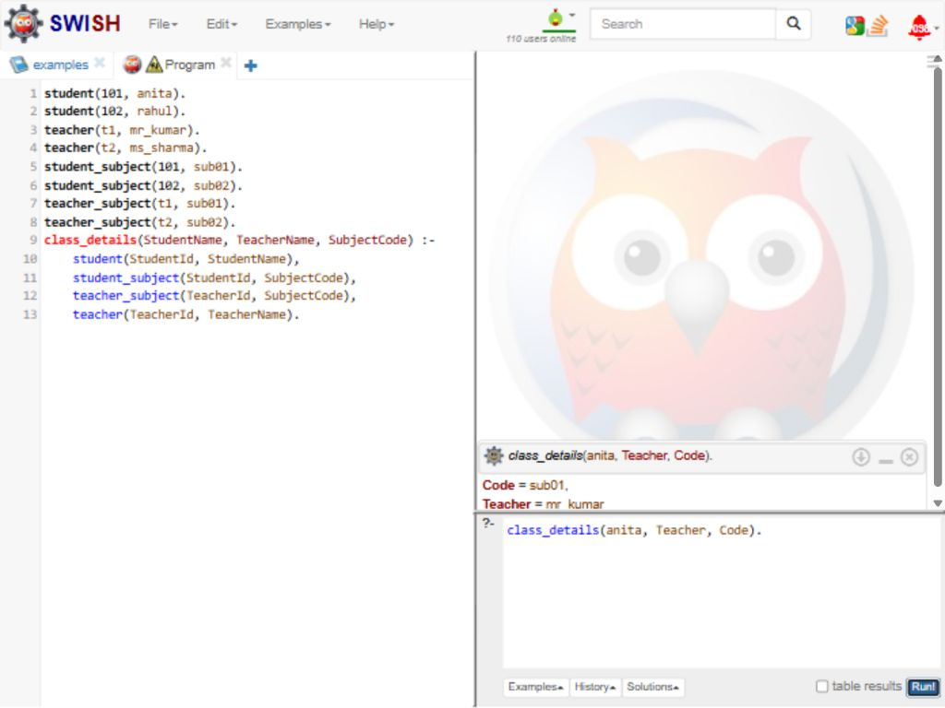
RESULT
Thus, the Prolog database returned Mr Kumar and subject code sub01 for student Anita.

